ASSIGN SWAP PARTNER/CLIENT ACCESS RIGHTS TO USERS

STEP 1 (For HR and SuperAdmin user only):

* Go to settings -> user-> user -> open user to assign partner swap rights

* Go to bottom of page and check the box “Swap Partner”

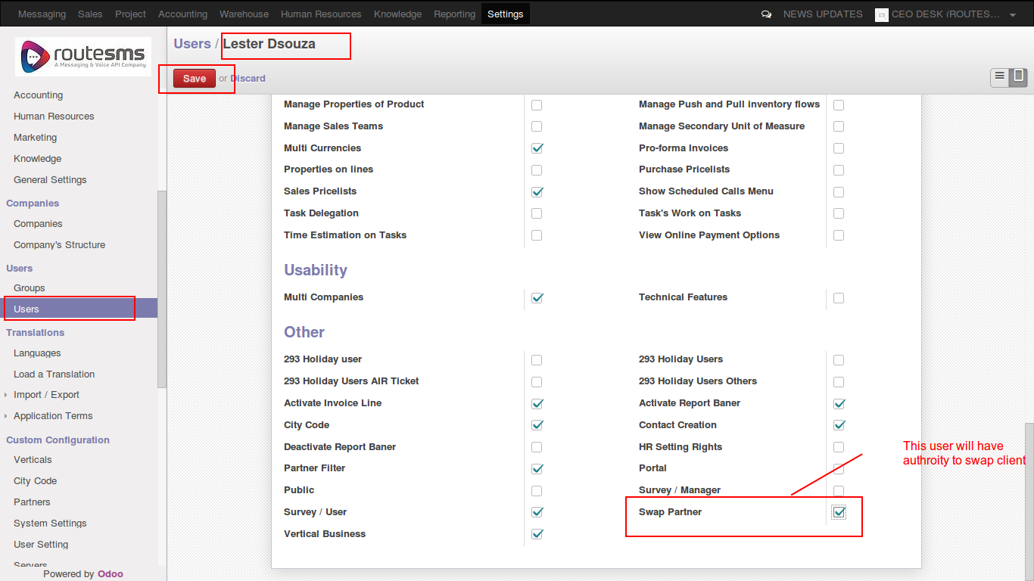

STEP 2 (For Sale user only):

* Go to partner/client to swap

* Click “More” button and click “Swap/Migrate Partner”

* This option is visible to those users only who has “swap partner” authority
(marked by HR in step 1)

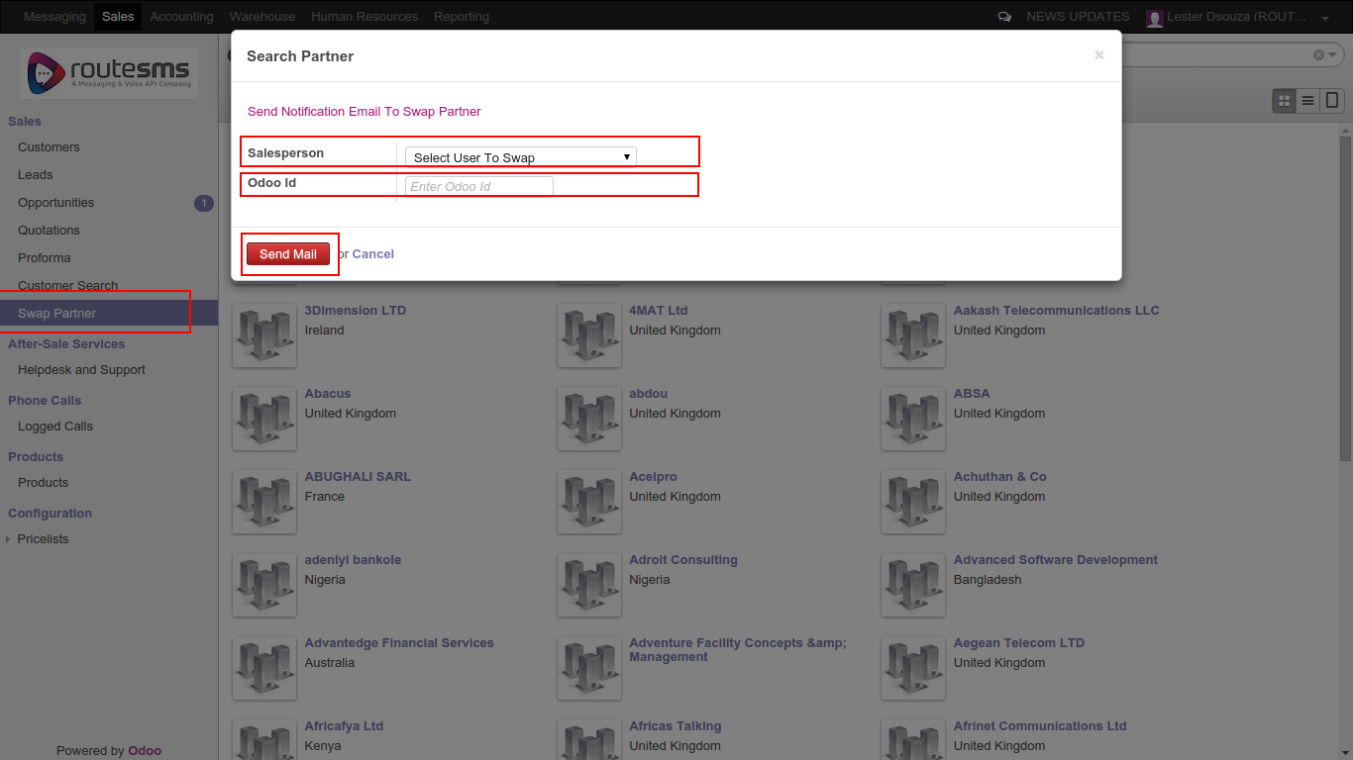

THANK YOU

